|  |
| --- |
|  |
| Innovation and Technology Management report For Light Vehicle Greenhouse Gas Emission Project |
| |  |  |  | | --- | --- | --- | | Abhishek Kakkar (s3827314) | 10/6/20 | Words Count: 2550 (Approx.) | |

Table of Content s

Executive Summary: 2

Project Overview: 3

Innovation suggested in the project Introduction: 4

Introduction and Market Scale: 5

Business case and Risk Study: 6

Current Practice and limitations: 7

Benefits of using Regenerative Braking System: 8

Uniqueness and Reasons behind the success of the proposed approach: 9

Economic Comparison of Regenerative Braking System: 10

Risk Analysis: 11

Midterm and Final exams of success: 12

Future Considerations: 12

Intellectual property: 13

Internal and External Stakeholders: 14

Conclusion: 15

References 16

# Executive Summary:

The report briefly describes the implementation and introduction of new technology/innovation in the Light Vehicle Greenhouse Gas (GHG) Emissions Project. This innovation will help us achieving our project goal more efficiently.

Regenerative Braking system (RBS) is proposed as an innovation for project which convert and stores excessive energy in battery of vehicles. The report will justify the use of Regenerative Braking system (RBS) effectiveness using Heilmeier’s catechism approach which will also helps in developing of business case and implementation of this technology in a proper way. With this technology implementation, the implications of Intellectual property (IP) and vital internal and external stakeholders that are considered are discussed in the report to avoid legal problems or lawsuits and conflict among the stakeholders.

# Project Overview:

The Light Vehicle Greenhouse Gas (GHG) Emissions project is the project of Australian government to the fight against climate change and emissions caused by light vehicle. As Australia is one of the important contributors in Paris Agreement. The aim of the project is reducing the carbon footprints and emissions caused by vehicles or increased energy conservation or fuel efficiency of the vehicle. To achieve the best possible outcomes of project government has used alliance data, in which National Transport Commission report tells every year the carbon emissions on basis of new vehicles sold in Australia. The annual sales data is provided by the Federal Chamber of Automotive Industries (FCAI). This data helps government about the Australia’s purchasing trends and the impact on carbon emission so they can implement policies and technology effectively.

# Innovation suggested in the project Introduction:

The innovation that has been chosen for the Greenhouse Gas Emission is regenerative braking system. A regenerative braking system (RBS) is a mechanism for energy recovery which converts the kinetic energy into electric energy and this energy can be stored and used whenever needed (A. Ahmed, 2011). The stored energy is utilized such as start-stop function, headlights, also to power the vehicle's interior electronics and rest stored and RBS behaves as a generator and generates electricity (IJSER, 2017). The electricity generated is then used for recharging the battery process shown in Figure1:

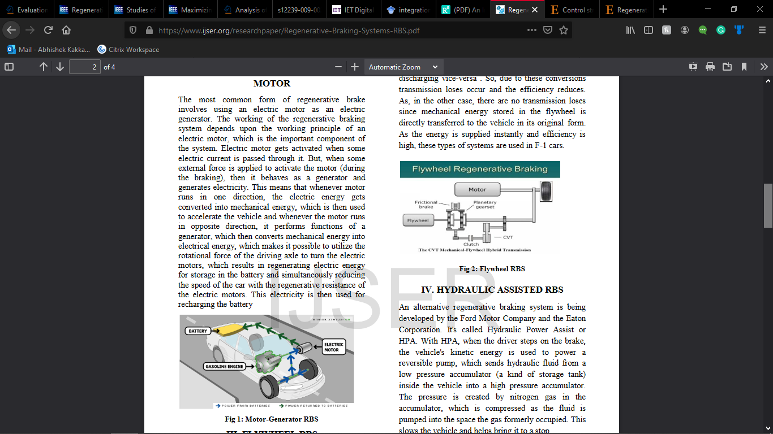

Figure 1: Energy recovery of Regenerative Braking System   
Source (IJSER, 2017)

Introduction and Market Scale:  
The automobile industry in Australia is growing rapidly. The global vehicle sales in the year 2016 reached approximately 88 million, registering a growth of 4.8% as compared to 2015 (BIS, 2018). As number of cars increasing on road simultaneously the increase in emission is observed. The modern automobile industry is continuously improving innovation in vehicles to reduces emissions. The upgradation or implementing new technology has shown promising result to minimise the risk associated to achieve our target. It is mentioned that by regenerative braking control strategy can achieve recovery energy up to 28.29% (M. Lv, 2017). It is been said that the global automotive market for regenerative braking system has seen remarkable growth and it is expected to rise at a CAGR (compound annual growth rate) of 11% by 2023 (Market Research Future, 2020). The [market value of automotive regenerative braking systems](https://www.globenewswire.com/Tracker?data=nQ75AHICgsMYTMH0rUj3lVf42m4MC6VcxY1ANBpYCu0QzjBagSUzkef_BAGq80-gpnZjD-QtfDvoiSw2I9Cm7SGNOpuF0EB9RyrhugUE8WNGI0xi3ZYSW5iz9NvTdCaYe0Uz4hKlhopoMwxrreAmdE-xYXceIQMhTQdfDNwVnyubhDdAbHwh-928Nrop_alIEb-HnYqiyno6OfwukWVTQ0wLvZ03nitYCSgNL8cTWEi3TS6Ly0ZRVdgLxtHMDNOiIyWgMXNt1JZ3yOjyJcJxge16c4PO5dgoWmABy4HHuGsy_FOet0ZG9YIhHbCvSJPMoZAt1DrfomCot9ZHOmhZbw==) will reach 6 billion USD by 2026 (Selbyville, 2020). The reason for increase in market value of braking system in upcoming years is because this system is used in various regions, systems and vehicle type as shown in Figure 2.

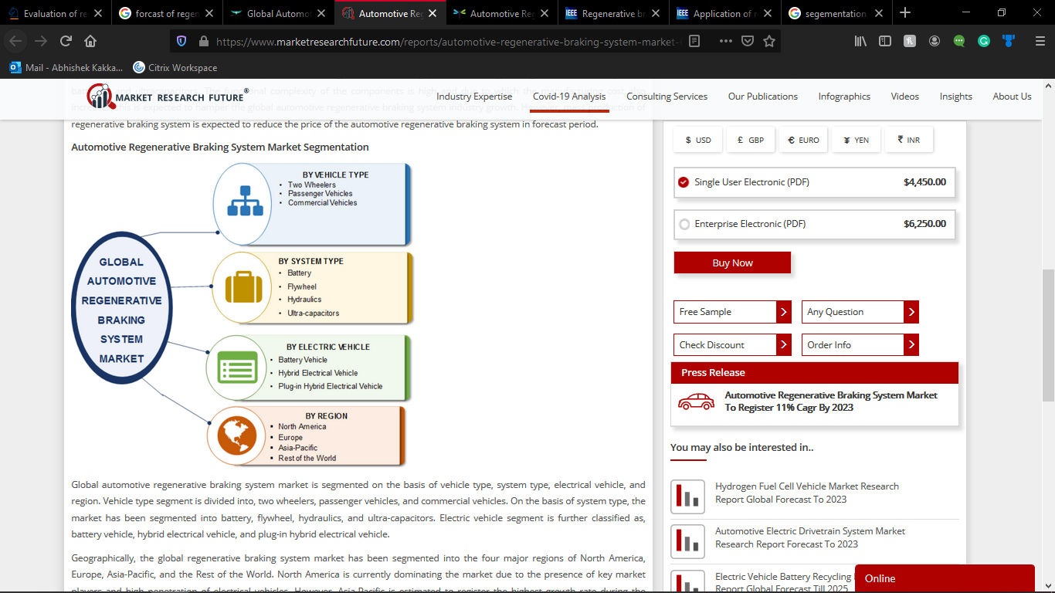

Figure 2: Regenerative braking system market segmentation   
Source: (Market Research Future, 2020).

# Business case and Risk Study:

Transportation represents a significant contribution of 17% GHG emissions in Australia in which light vehicle accountable for 50% alone, with the aim of reducing carbon footprints by transportation or automobile sector numerous innovations have been introduced and some even trying to improve the existing technology in last couple of years and RBS is one of the potential method to reduce pollution from the vehicles. Further sections of the report justify the use of regenerative braking system in the GHG Emission Project and to analyse the risk with the undertaking of this technology.

Current Practice and limitations:  
The current method used to reduce emission is to buy new electric vehicles or hybrid vehicles. In this context the, not every single can buy because these vehicles are very expensive. (Harrison, 2020) The most affordable electric vehicle available at the price of AUD 49,500 (before on roads). To add on the other limitation charging station of such vehicles is very less in number.

The current practice of energy conservation in regenerative braking is done by fuzzy logic/ fuzzy control strategy. Fuzzy control strategy helps the braking force to distribute force evenly between the rear and front wheels (M. Lv, 2017).

* In this context, the first limitation of the current practice is as the results are based on simulation or software environment, so all the conditions were idle. As in real time several conditions vary from time to time such as in highly areas the energy needed or consumed by vehicle is more.
* The second limitation is in this control strategy the braking system we use mechanical components (hydraulics). By using mechanical system several losses take place in form of vibration and heat.

The other practice to restored energy is EMB (electro – mechanical brake) instead of EHB (electro- hydraulic brake) in regenerative braking system. This technology is currently found in ESP (electronic stability program) (J. K Ahn, 2009).

* The first limitation, as the result is based on simulation software (MATLAB). Therefore, no real conditions were considered which varies like every individual has its own way of driving a vehicle. Some drivers use for more brake or press brake pedal hard which leads to loss of energy.
* The current researches on this braking system have failed to conider the most popular braking system used today which is anti-lock braking system (ABS). The safety of vehicle is questionable as none shown impact on ABS (anti – lock braking sytem) so there a possibility while braking the wheel get lock and driver will not able to the steer wheels to safety refer to Figure 2 [1].

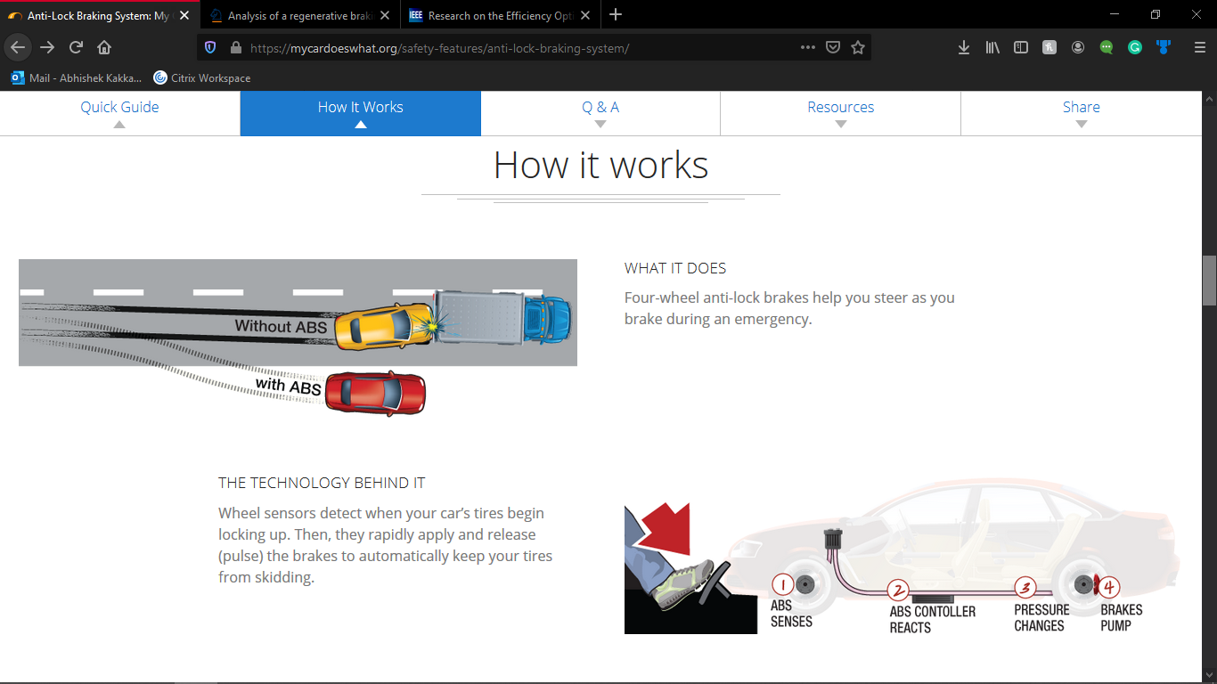

Figure 2: **Comparison of vehicle with ABS and Without ABS** Source: [1]

# Benefits of using Regenerative Braking System:

The objectives to be accomplished through the innovation proposed in the Light Vehicle Greenhouse Gas Emission project are as follows-

* To increase energy conservation within the vehicle.
* To minimize the consumption of fuel in the vehicle.
* To reduce emission and carbon footprints because to reduce impact on climate change.

The braking system of a vehicle is generally based on hydraulic braking technology which is a traditional way. By this technology methodology vehicle waste lot of energy since it produces unwanted heat during braking (M. K Yoong, 2010).

Researchers also mentioned by key technology the regenerative braking system improve fuel efficiency by 20 - 50%. The reason it is developed to improve fuel consumption and vehicle safety (J.K Ahn, 2009). By this control strategy simulation has showed that the energy recovery increased up to 29% (M. Lv, 2017).

# Uniqueness and Reasons behind the success of the proposed approach:

The use of regenerative braking system (RBS) in light vehicles can be significantly beneficial for the Light Vehicle Greenhouse Gas (GHG) Emission project

* In brief, the RBS will primarily help to save and stored more energy in battery for the vehicle.

The uniqueness behind the incorporation of regenerative braking in the project is that will help us to reach our Paris agreement target to reduce GHG from 26% to 28% by 2030. By using regenerative braking, it has become one of the ways to improve the driving range as this method can increase an vehicles driving range by 8−25% (M. K Yoong, 2010) To add on there are various advantages of using regenerative braking over traditional braking system (M. K Yoong, 2010):

* More effective and efficient in stop and go driving conditions.
* Prevents wear on mechanical parts within in the braking system. Hence low maintenance cost and more reliable.
* More energy stored. Therefore, better fuel economy of the vehicle and the life span of the batteries also increased.
* More control over braking which will help make the vehicle safe.

# Economic Comparison of Regenerative Braking System:

Cost is one of the important factors considered by the project managers before implementation of any innovation into the project. A company in India converts your exiting vehicle into hybrid vehicle under AUD 1200(INR 60000) which very low as compare to electric vehicle (AUD 49,500 before on - roads). The company (ALTIGreen Drive Electric) stated that” Our proprietary, low cost, retrofit Hybrid Intelligent Exchange drive systems convert fossil fuel-based vehicle that are in use into hybrids. With advance regenerative braking, the system is grid independent, requiring no external charging”. By this mileage of vehicle will improve by 25%. Hence, this technology is beneficial for economic and environmental aspects it is a good option for our GHG Emission Project.

# Risk Analysis:

Term risk is defined as an unreliable event which may have positive or negative effect on the project objective (Srivinas 2019). Before implementing any technology in any project risk analysis is done to see possible risks and strategy of mitigating them. Risk analysis is mostly implemented at the beginning of the project to identify risk so that to ensure the best value of project in terms of cost, time, and quality.

Following are the risk identified associated with implementation of Regenerative Braking System in GHG Emission Project.

Table 1: Risk Identified in GHG Emission Project

|  |  |  |  |
| --- | --- | --- | --- |
| ID | Risk Category | Identified risk | Mitigation Strategy |
| 1 | Market | Technological changes or New technology available | Research and development department should contact  organization and stakeholder with upcoming technology |
| 2 | Market | Change in customer demand | Constant eyes at the consumer market and trends |
| 3 | Technical | Alterations in production | Proper production team to schedule the manufacturing of certain product |
| 4 | Technical | Product quality problems. Not optimal design as required for project. | Direct meeting of technical team with project teams |
| 5 | Technical | Product specification is not as per demand of product | Supervisors and Engineers should constantly audit and check the product when in manufacturing process |
| 6 | Organisational | Supplier failure on provided material on time | More communication between administration and logistic department |
| 7 | Organisational | Transportation failure. Delivery chain disruptions | Continuous tracking of vehicle or communication with driver or tie up near transport companies |
| 8 | Political | Increased raw material prices | Already stock enough material for the demanded order |
| 9 | Political | Tax increases | Accept the risk. Communication between organizations and government as it is the government-oriented project |
| 10 | Political | Policies changed by government | Accept the risk. Meetings between stakeholders and government |

# Midterm and Final exams of success:

The Light Vehicle Greenhouse Gas (GHG) Emissions Project has numerous ranges of objectives and gals which cannot be compromised. The implementation of the regenerative braking system technology and its development must be evaluated at different stages to optimise and impact on the project.

Initial Stage Small – Scale implementation: To evaluate the efficiency of the new technology it must be implemented at smaller scale before producing in high scale. The small scale will help us to understand the any flaws or in which the RBS needed the improvement to work effectively for the project. The RBS kit is currently implemented in smaller scale the company ”ALTIGreen“ is situated in Bangalore, India and they are currently implanting system in the every type vehicle (Two- wheelers, Light vehicle, Heavy vehicle, Tuk – tuk) of Bangalore city and have shown promising result.

Large Scale implementation – After receiving the promising result continuously and analysing the performance result at small scale, the new technology can be implemented at larger scale. The government of India has endorsed and supported regarding big scale implementation of innovation, so they can start manufacturing RBS kit in high range to keep up demand. The success of the innovation can influence the internal and external stakeholders which lead to more improvement in the technology.

# Future Considerations:

Currently the regenerative braking system (RBS) can be used any sort of vehicles but majorly used only for light vehicle if RBS used for much wider applications it will help us to reach our target in reduction carbon footprints. To successfully implement this innovation at large scale in future there is urgent need for more research initiatives and improvement required in this area and also to aware the people about the benefits of the technology and the impact it will make our environment.

# Intellectual property:

(World Intellectual Property Organization) Intellectual property is protected in law by patents, copyright, innovations, designs and trademarks, trade secrets, which helps people to earn recognition and financial benefit for what they invented or created to help the society.

Intellectual property is not an important factor in context because all the companies has currently started implementing with new technology in new hybrid vehicle and design and structure is same for regenerative braking system and also the implementation of innovation will be done in alliance with big companies as all companies already have innovation so no implication with its implementation. This Technology can be integrated in the Light Vehicle Greenhouse Gas Emissions Project with collaboration of firms.

Internal and External Stakeholders:   
A stakeholder is a party that has an interest in a project and can either affect or can be affected by the performance and business of the technology (James, 2020).The stakeholder can influence whether to launch technology with more financial profit or economical profit . The implementation of the any technology in any project is not possible without cooperation and mutual understanding within the internal and external stakeholders. The key internal and external stakeholders in context of the regenerative braking system and Light Vehicle Greenhouse Gas Emissions Project are as follows:

Table 2: List of internal and external stakeholders

|  |  |  |  |
| --- | --- | --- | --- |
| Stakeholders | Category | Stakeholder interest and role | Involvement |
| Government | Internal | The incorporation of this innovation will significantly result to reach our target in reduction of GHG (greenhouse gas) emissions and the government will invest more towards the improvement in this area | Throughout |
| Manufacturing firms | Internal | As for the implementation of innovation in cars and making of innovation we need help of automobile industry. The biggest interest of organisation is the profit they make out of it. As the innovation will be needed in high range. The global vehicle sales in the year 2016 reached approximately 88 million, registering a growth of 4.8% as compared to 2015 (IJSER, 2017). | Throughout |
| Workers | External | Because of the high production of innovation. The high production will help increase shifts for the workers and similar high wages. | Operational phase |
| Project team | Internal | As the innovation will help the project team to achieve target. Therefore, the project team can focus more other ways to reduce emission and fuel consumption. To add on they will gain valuable experience. | Throughout |
| Suppliers/Distributors | External | The innovation can help the distributors in gaining profitability through sales of technological equipment. | Operational |
| General Public | External | The innovation would benefit the public of Australia to get more cleaner environment and now they can buy vehicle caring little less about climate change as they will be impacting less on environment. | After completion |

# Conclusion:

The implementation of Regenerative Braking System (RBS) in the Light Vehicle Greenhouse Gas Emission project is an ideal option considering to achieve our target in reducing the emissions and reducing our impact on climate change, but further improvement is necessary in this area. For more effective results or reduction of emission, reduction of fuel consumption RBS should be implemented on every type of vehicles available on road.

# References

A. Ahmed and S. Cui, "Control and analysis of regenerative power distribution on electrical variable transmission using fuzzy logic on HEV system," 2011 International Conference on Electrical Machines and Systems, Beijing, 2011, pp. 1-6, doi: 10.1109/ICEMS.2011.6073441. [Online] Available at:   
<<https://ieeexplore-ieee-org.ezproxy.lib.rmit.edu.au/document/6073441>>

P. Bhandari, S. Dubey, S. Kandu, R. Deshbhratar “Research Braking system” International Journal of Scientific & Engineering Research, Volume 8, Issue 2, February-2017 ISSN 2229-5518 [Online] Available at:   
<<https://www.ijser.org/researchpaper/Regenerative-Braking-Systems-RBS.pdf>>

[BIS Reaseach ”Global Automotive Regenerative Braking System Market - Analysis and Forecast: 2017–2026](BIS%20Reaseach%20”Global%20Automotive%20Regenerative%20Braking%20System%20Market%20-%20Analysis%20and%20Forecast:%202017–2026)”, April 2018. [online] Available at:   
< <https://blog.marketresearch.com/5-things-to-know-about-the-automotive-regenerative-braking-system-market>>

M. Lv, Z. Chen, Y. Yang and J. Bi, "Regenerative braking control strategy for a hybrid electric vehicle with rear axle electric drive," 2017 Chinese Automation Congress (CAC), Jinan, 2017, pp. 521-525, doi: 10.1109/CAC.2017.8242823. [online] Available at:   
< <https://ieeexplore-ieee-org.ezproxy.lib.rmit.edu.au/document/8242823>>

“Automotive Regenerative Braking System Market Research Report- Global Forecast till 2023” Septmeber,2020. [online] Available at:   
<<https://www.marketresearchfuture.com/reports/automotive-regenerative-braking-system-market-6919>>

Selbyville, Delaware, “Automotive Regenerative Braking System Market growth predicted at over 13% till 2026”, May, 2020. [online] Available at:   
<<https://www.globenewswire.com/news-release/2020/05/04/2026554/0/en/Automotive-Regenerative-Braking-System-Market-growth-predicted-at-over-13-till-2026-Global-Market-Insights-Inc.html>>

H.Astbury “Affordable Electric cars in Australia”, May 2020. [online] Available at: <<https://www.savings.com.au/car-loans/affordable-electric-cars-in-australia>>

M. K. Yoong et al., "Studies of regenerative braking in electric vehicle," 2010 IEEE Conference on Sustainable Utilization and Development in Engineering and Technology, Petaling Jaya, 2010, pp. 40-45, doi: 10.1109/STUDENT.2010.5686984. [online] Available at:  
< <https://ieeexplore-ieee-org.ezproxy.lib.rmit.edu.au/document/5686984>>.

Ahn, J.K., Jung, K.H., Kim, D.H. et al. Analysis of a regenerative braking system for Hybrid Electric Vehicles using an Electro-Mechanical Brake. Int.J Automot. Technol. **10,** 229–234 (2009). [online] Available at: <https:doi.org/10.1007/s12239-009-0027-z>  
<<https://link.springer.com/content/pdf/10.1007/s12239-009-0027-z.pdf>>

M. K. Yoong et al., "Studies of regenerative braking in electric vehicle," 2010 IEEE Conference on Sustainable Utilization and Development in Engineering and Technology, Petaling Jaya, 2010, pp. 40-45, doi: 10.1109/STUDENT.2010.5686984. [online] Available at:  
< <https://ieeexplore-ieee-org.ezproxy.lib.rmit.edu.au/document/5686984>>

The ALTIGreen. [online] Available at:   
<<http://hypixi.in/#!/product>>

Srinivas, K. (2019). ‘Process of Risk Management’, [Online] Available at: <<https://www.researchgate.net/publication/331783796_Process_of_Risk_Management>>

World Intellectual Property Organization (WIPO), [Online] Available at: <<https://www.wipo.int/about-ip/en/>>

James Chen “Stakeholder”, March 2020, [Online] Available at: <<https://www.investopedia.com/terms/s/stakeholder.asp>>

[1] [online] Available at: <<https://mycardoeswhat.org/safety-features/anti-lock-braking-system>>